Short Description About Project

This project report outlines the process of analyzing Tokyo Olympic data using various Azure services. The team, consisting of Ms. Mansi Jadhav, Mr. Jayesh Waingankar, and Mr. Yogesh Pawar, leveraged services like Azure Data Factory, Azure Synapse Analytics, Azure Databricks, and App Registration. The report includes detailed steps, challenges faced, and lessons learned throughout the project.

In this Project we have Dataset and we have done analyzation and visualization of the data. Dataset is provided in the github.

Diagram of Data Factory:-

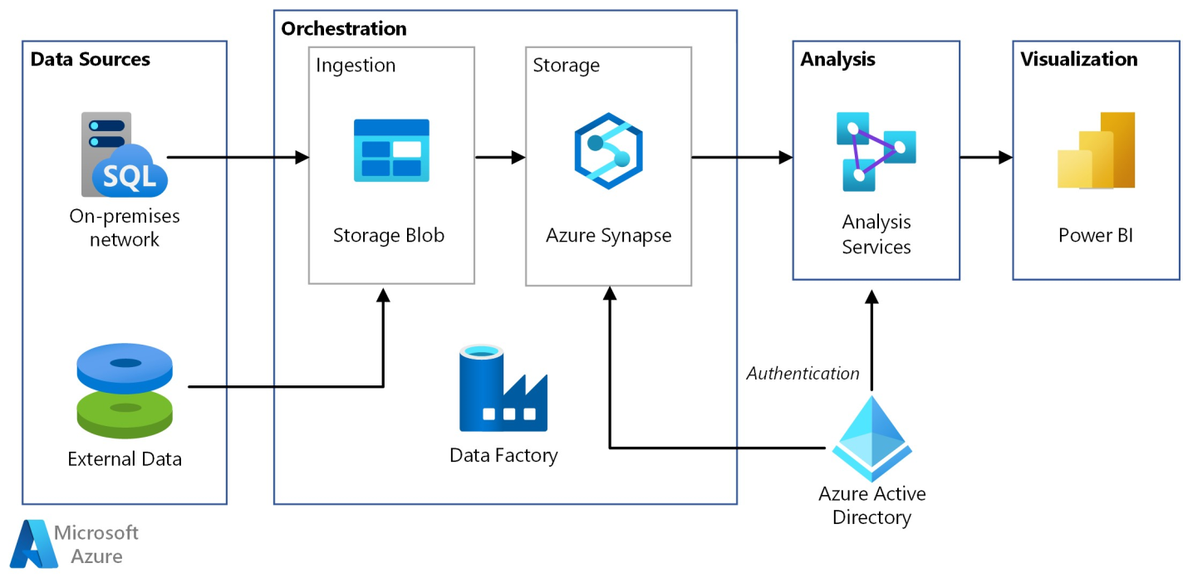

Here we have container and in that we have directory raw and transformed data

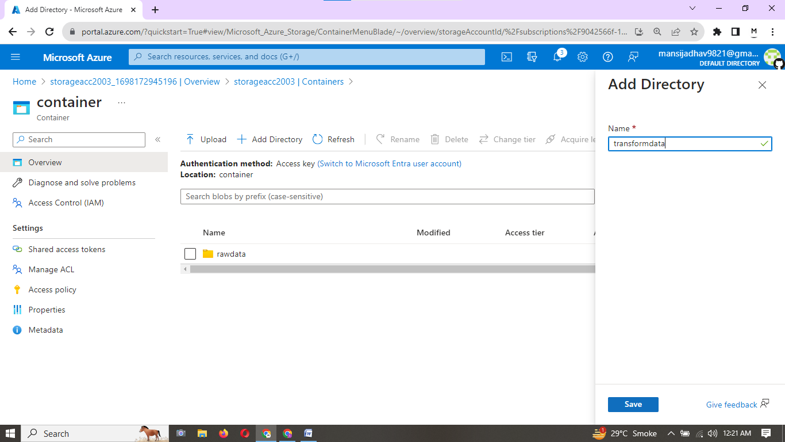

Here we create data factory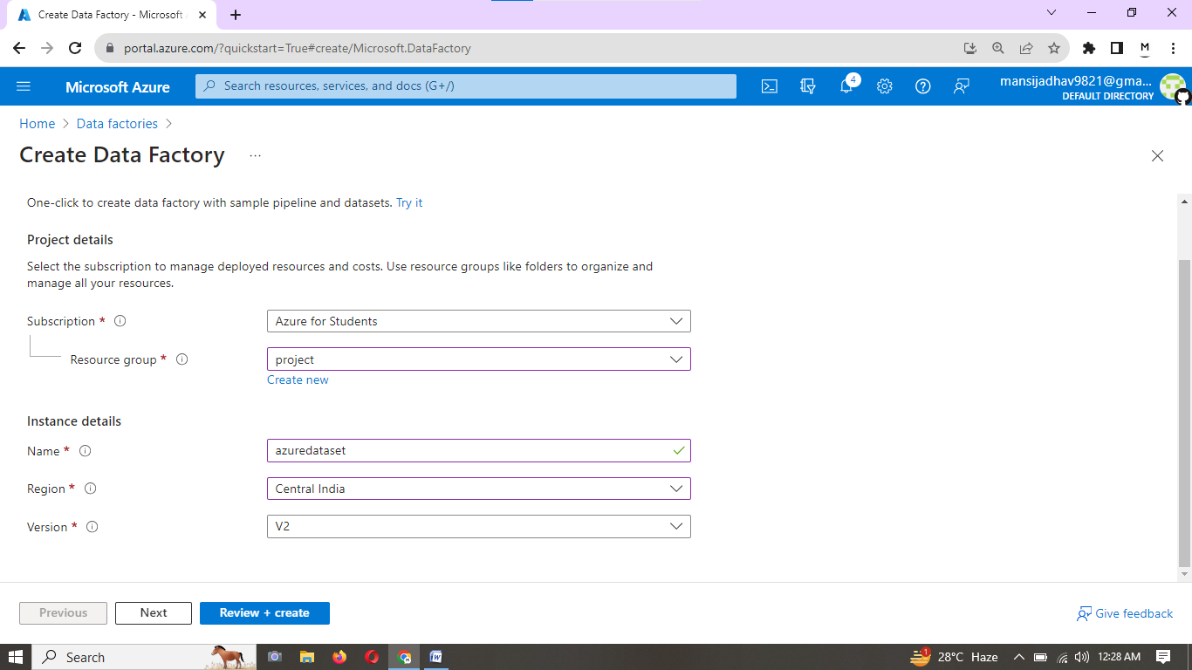

Console of data factory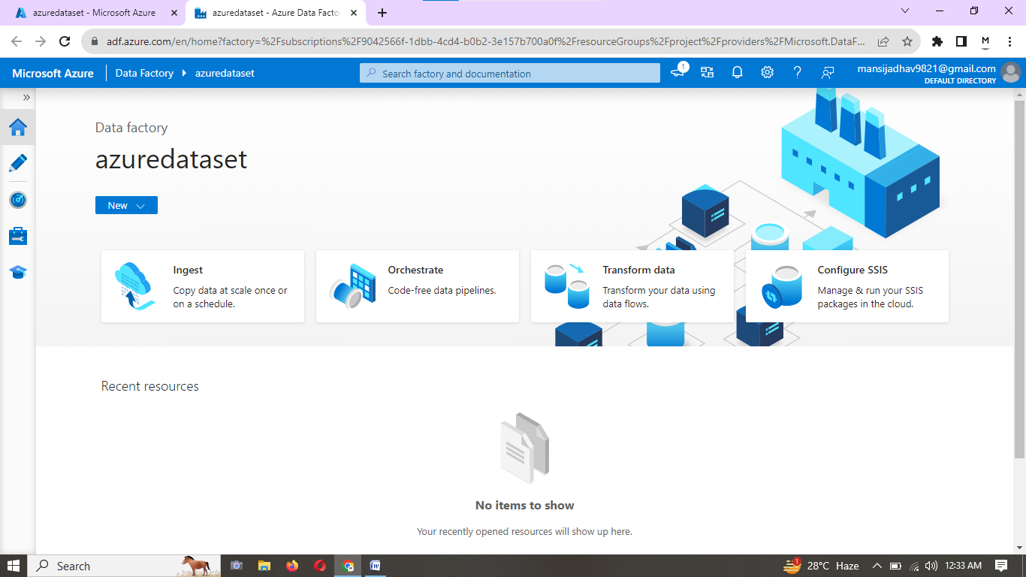

Preview Data of one of the dataset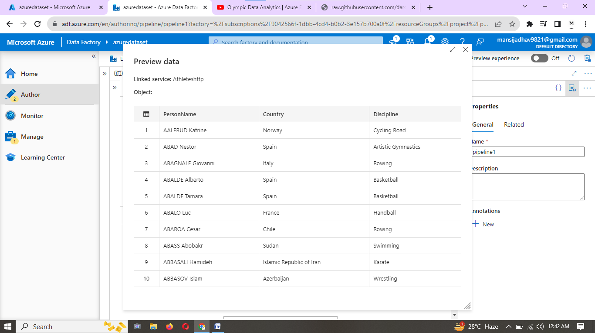

Pipeline created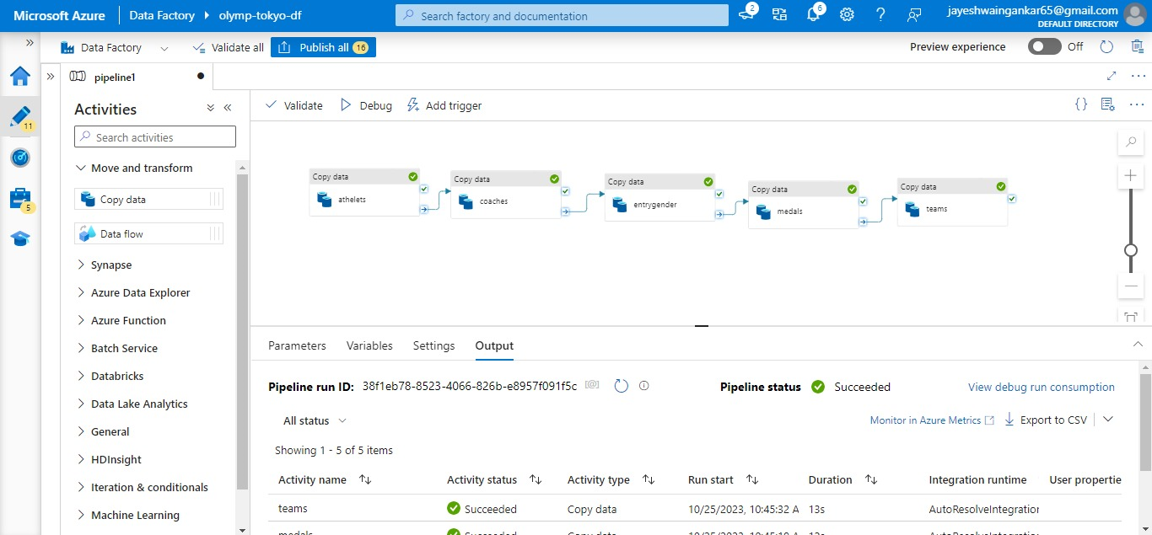

Azure Databricks console here we will write code for transformation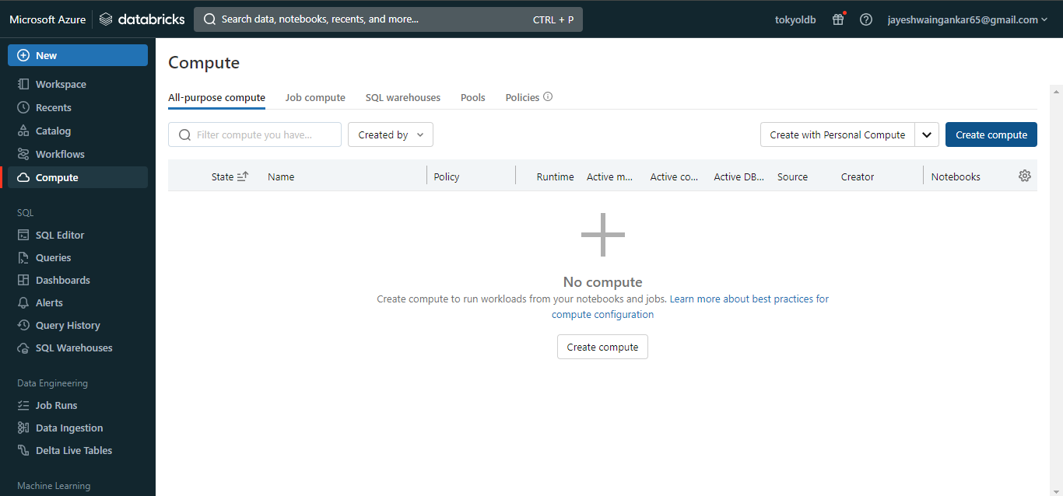

Azure Synapse Analyze where we will write our SQL query

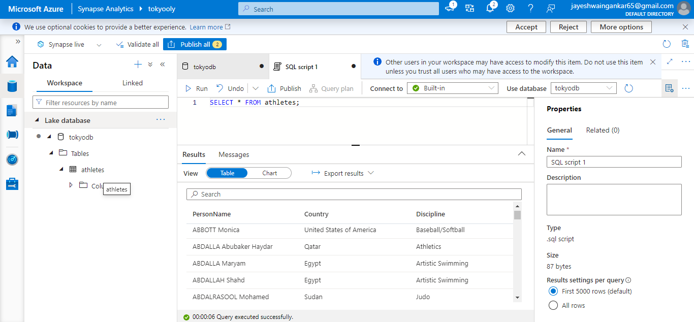

This is the viualization of the data using Powerbi. 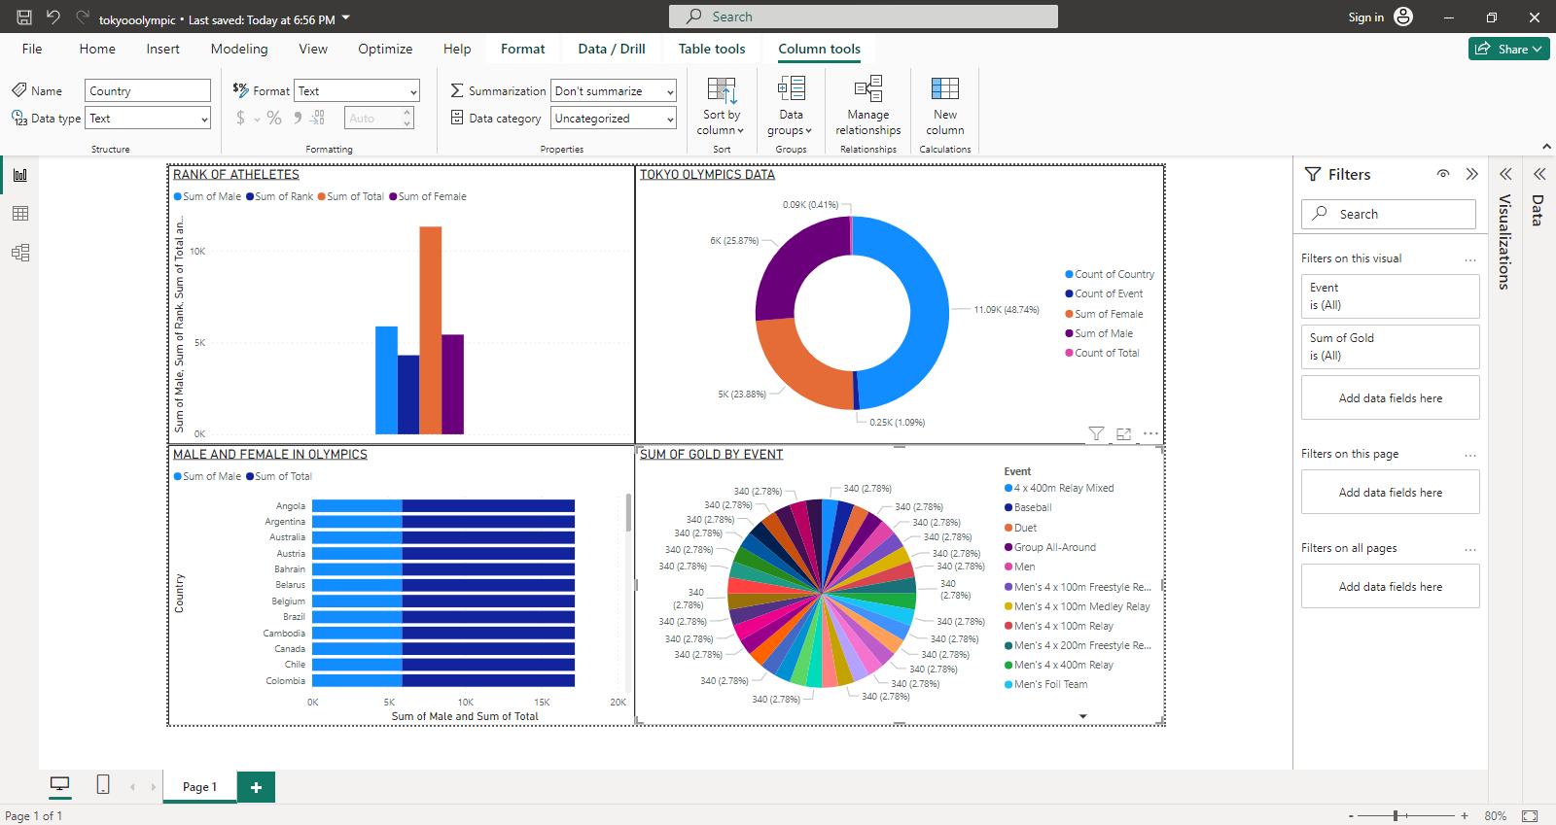

This project report showcases a well-structured approach to utilizing Azure services for data analysis, providing a valuable resource for others interested in similar endeavors.